EU-Certificate

EU- Declaration of conformity for machinery- IIB

PROHIBITION OF PUTTING INTO SERVICE

Manufacturer: Name: Rexnord N.V./S.A.
Dellingstraat 55
BE - 2800 Mechelen
Belgium

Description : Viva Couplings

We hereby declare that the product above conform with the essential specifications in the guideline:
Directive 98/37/EC of the European Parliament and the council of 22 June 1998 on the approximation of the laws of the member States relating to machinery. The machinery must not be put into service until the machinery into which it is to be incorporated has been declared in conformity with the provisions of the Directive.
E 811 Machineveiligheid - afstanden ter bescherming van de onderste

Date: Signature:

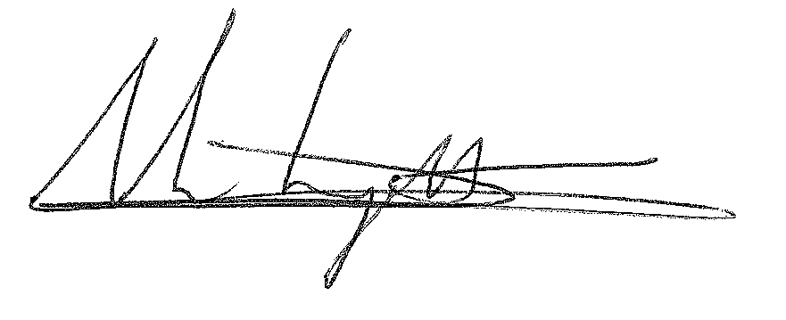

Name: François Vanderreydt

Function: Customer Service Manager
Rexnord NV

